Solution Architecture
AI FAQ Assistant — Backend-Only RESTful API (Node.js / Express.js / MongoDB / JWT / Gemini AI)
Field | Details
Date | 26 September 2026
Team ID | 6ab4aef20fc666a751b4634f
Project Name | AI FAQ Assistant
Maximum Marks | 4 Marks

1. Purpose / Goals
The business problem this architecture solves is that FAQ content is slow and repetitive to write and maintain by hand — whoever owns a knowledge base has to think up questions, phrase answers accurately, and keep everything current as things change. The AI FAQ Assistant removes that bottleneck by letting a user manage FAQs directly and delegate the writing work to AI: a free-text question gets an instant Gemini-generated answer, and a topic gets a structured, ready-to-save question/answer pair. The architecture is therefore the bridge between that problem and the technology chosen to solve it — it makes sure every layer (Express API, middleware, controllers, models, services, database and the external Gemini API) is the best fit for the job, rather than an arbitrary collection of tools. Concretely, the goals of this solution architecture, applied to this project, are:
1. Identify the best-fit technology solution — select the technology that solves the FAQ-content problem efficiently and economically: Node.js/Express.js for a lightweight, stateless JSON API, MongoDB/Mongoose for flexible FAQ documents, JWT for secure stateless access, and the hosted Google Gemini API for AI generation with no local ML infrastructure, training pipeline or hardware cost.
2. Describe the structure and behavior of the solution to stakeholders — present the layered architecture (client → API → middleware → controllers → models/services → database and AI API) so that anyone can see how a request travels through the system, how authentication and ownership are enforced, and where the AI integration sits, without reading the source code.
3. Define the features, phases and requirements of the solution — connect each architectural element back to the requirements it delivers (authentication, FAQ CRUD with creator ownership, search, AI answer and AI FAQ generation), and to the phased delivery of those features across the three sprints.
4. Provide specifications for how the solution is delivered, deployed and maintained — specify the MVC folder structure, the environment-variable configuration contract (.env), the error-handling and validation conventions every endpoint follows, and the deployment model (local Node.js server for development; any Node-compatible host with MongoDB Atlas for production), so the API can be built, run and extended consistently.

2. Architecture Diagram Description
The diagram is a top-to-bottom layered stack (client at the top, data and external services at the bottom), with vertical arrows showing the request path and return arrows showing the response path. It can be drawn directly as follows:
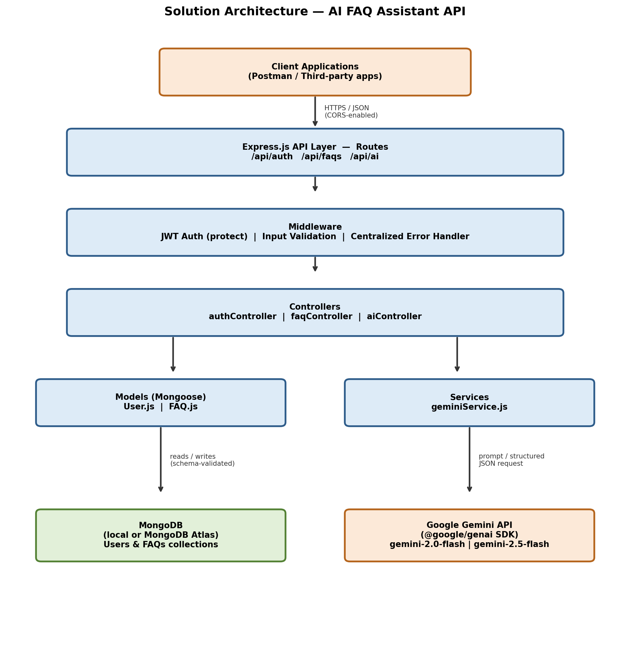
Figure 1: Solution Architecture Diagram
Layer 1 — Client Applications (top box). A box labeled "Client Applications" containing Postman (the pre-built collection with automatic JWT token capture) and third-party client apps. An arrow leaves the bottom of this box labeled "HTTPS / JSON (CORS-enabled)" and points down into Layer 2.
Layer 2 — Express.js API Layer (routing box). A box labeled "Express.js API Layer" containing three grouped route boxes: /api/auth (register, login, profile), /api/faqs (create, list, get by ID, update, delete, search) and /api/ai (answer, generate-faq). Each route box has an arrow pointing down into the middleware chain (Layer 3).
Layer 3 — Middleware (horizontal chain of three small boxes). Three boxes side by side inside a "Middleware" band: protect (JWT authentication) — verifies the Bearer <token> header, and applies to the protected /api/faqs write routes, /api/auth/profile and /api/ai/*; Input validation — screens request bodies (required fields, email format, password length ≥ 6, valid category, non-empty AI input) before any controller runs; Centralized error handler — a single box that every layer feeds failures into, with an arrow going back up to the Client Applications box labeled "consistent JSON error response (no stack traces)". Arrows continue downward from the middleware band into Layer 4.
Layer 4 — Controllers (business-flow box). A box labeled "Controllers" containing three boxes: authController, faqController and aiController. Each controller receives the validated request and orchestrates the work by calling down into Layer 5.
Layer 5 — Split into two parallel columns: the left column, Models (Mongoose) — boxes User.js and FAQ.js; and the right column, Services — box geminiService.js.
Layer 6 — Data store and external API (bottom boxes): MongoDB (local or Atlas) on the bottom-left, with an arrow from the Models column pointing down labeled "read / write documents" and a return arrow pointing back up; and Google Gemini API (@google/genai SDK) on the bottom-right, with an arrow from the Services column pointing down labeled "gemini-2.0-flash (direct answers) / gemini-2.5-flash (structured JSON schema for FAQ pairs)" and a return arrow labeled "answer text / {question, answer} JSON".
Annotations (dashed side notes): a dashed "Environment variables (.env)" note pointing at both the MongoDB connection (MONGO_URI) and the Gemini call (GEMINI_API_KEY), plus dashed notes for PORT, JWT_SECRET and the CORS policy on the API layer.

3. Component Behavior
Client Applications (Postman / third-party apps). Clients speak only HTTPS/JSON and hold the JWT after login or registration; the shipped Postman collection stores that token automatically, so protected requests carry Authorization: Bearer <token> with no manual handling. A client never touches the database or the Gemini API directly — every operation is an HTTP call into the API layer.
Express.js API Layer (routes). The API layer is the single entry point: it maps each URL under /api/auth, /api/faqs and /api/ai to the correct controller method, applies CORS so any client origin can consume the API, and returns every response as JSON. In a typical request, the route first decides whether the endpoint is public (GET /api/faqs, GET /api/faqs/:id, GET /api/faqs/search) or protected, and chains the appropriate middleware accordingly.
Middleware. Middleware runs before any controller: the protect function verifies and decodes the JWT and attaches the authenticated user to the request (rejecting missing, invalid or expired tokens with 401), the validation middleware rejects malformed bodies with 400 before any business logic or database access happens, and the centralized error handler catches everything thrown downstream — Mongoose validation errors, CastErrors, duplicate-key errors, 401/403 — and converts it into one consistent JSON error format without leaking stack traces.
Controllers. Controllers hold the request/response flow only — they read the validated input, call the right model or service, and map the outcome to the correct HTTP status and JSON payload. For example aiController receives the topic, calls geminiService, and returns the generated pair; it contains no AI logic and no query logic itself.
Models (Mongoose: User.js, FAQ.js). Models define the schema and validation rules (user name/email/password; FAQ question/answer/category enum and createdBy reference) and are the only layer that talks to MongoDB, so authController and faqController never write raw queries. On a write, the model stamps the creator and timestamps; on a read, it applies sorting (newest first) and population (creator name/email).
Services (geminiService.js). The service layer isolates all third-party AI concerns — SDK client creation, model selection, prompt/schema construction and response handling — behind a plain function the controller can call. This keeps the Gemini integration swappable and testable, and keeps AI latency and API failures contained in one place.
Database (MongoDB, local or Atlas). MongoDB stores two collections — users and FAQs — reached through the MONGO_URI connection string, so the same code runs against a local instance in development and a managed Atlas cluster in production, selected purely by configuration.
External AI API (Google Gemini). Gemini is called only by the service layer using the @google/genai SDK: gemini-2.0-flash returns a direct answer to a free-text question, while gemini-2.5-flash is called with a structured JSON schema so a topic returns a well-formed {question, answer} pair. Its latency and availability are outside the project's control, which is exactly why the call is isolated behind the service layer.
End-to-end trace — POST /api/ai/generate-faq (typical request):
1. Postman sends the topic in the JSON body over HTTPS with the auto-captured Bearer <token>.
2. The /api/ai route matches the endpoint and passes the request through the protect middleware (JWT verified, user attached) and the validation middleware (topic must be non-empty).
3. aiController receives the validated topic and calls geminiService.
4. geminiService calls Gemini (gemini-2.5-flash) with the topic plus the structured JSON schema, using the key from GEMINI_API_KEY.
5. Gemini returns a structured {question, answer} pair, which the service passes back to the controller.
6. aiController returns 200 OK with the generated pair; the client can then save it with POST /api/faqs, which follows the same middleware chain and persists it through the FAQ.js model with the user as creator.
7. If any step fails — no/invalid token, empty topic, Gemini error — the centralized error handler returns a consistent JSON error instead of an unhandled crash.

4. Key Design Decisions & Justification
1. Stateless JWT authentication instead of server-side sessions. Because the API is consumed by Postman and arbitrary third-party clients rather than one browser, a stateless token is the natural fit: no session store, no sticky sessions, and any request can be authenticated on its own, which lets the API scale horizontally behind a load balancer with every instance sharing the same MongoDB database. The trade-off — tokens cannot be revoked before expiry — is acceptable for this project's scope, and tokens are signed with a JWT_SECRET supplied through environment variables.
2. Isolating the AI integration in a dedicated service layer (geminiService.js) instead of calling Gemini from the controllers. Keeping controllers free of SDK, prompt and schema details preserves the MVC separation used everywhere else in the project (routes → controllers → services/models) and confines the two things most likely to change or fail — the model name and the prompt/schema format — to a single file. This proved its worth during testing, when the Gemini model name had to be updated: the fix was a one-file change with no controller or route touched.
3. MongoDB with Mongoose instead of a relational database. FAQ entries are naturally flexible documents — a question, an answer, a category from a fixed set, a creator reference and timestamps — with no joins or transactions to model, so a document store keeps the schema simple and lets fields evolve without migrations. Mongoose adds schema-level validation and an ODM layer, so category rules and required fields are enforced at the model rather than scattered through controller code.
4. Using Gemini's structured JSON output for FAQ generation instead of parsing free text. Asking for a free-text answer and then parsing it into a question/answer pair would be fragile — any change in phrasing would break the split. Supplying a JSON schema makes the model return a predictable {question, answer} object that can be validated and saved directly through the existing Create FAQ endpoint, which is what makes the "generate then save" flow reliable.
5. A centralized validation-and-error middleware chain instead of per-route checks. Validating every body in one place and funneling every failure through one error handler guarantees a uniform JSON error contract for the whole API, prevents unvalidated input from ever reaching the database or the Gemini API, and keeps stack traces and internal details out of client responses.

